1 | Chords  Intro | 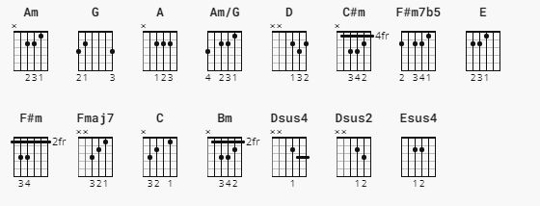  Am Am/G F#m7b5 Fmaj7 Am G D E
2 | Verse 1 | Am Am/G F#m7b5 Fmaj7  I look at you all, see the love there that's sleeping  Am G D Dsus4 D Dsus2 D Esus4 E  While my guitar gently weeps  Am Am/G F#m7b5 Fmaj7 Am G C E  I look at the floor, and I see it needs sweeping - Still my guitar gently weeps
3 | Chorus  1 | A C#m F#m C#m Bm E Esus4 E  I don't know why nobody told you - How to unfold your love  A C#m F#m C#m Bm E Esus4 E  I don't know how someone controlled you - They bought and sold you
4 | Verse 2 | Am Am/G F#m7b5 Fmaj7  I look at the world, and I notice it's turning  Am G D Dsus4 D Dsus2 D Esus4 E  While my guitar gently weeps  Am Am/G F#m7b5 Fmaj7 Am G C E  With every mistake we must surely be learning - Still my guitar gently weeps
5 | SOLO | Am Am/G F#m7b5 Fmaj7 - Am G D E  Am Am/G F#m7b5 Fmaj7 - Am G C E
6 | Chorus 2 | A C#m F#m C#m Bm E Esus4 E  I don't know how you were diverted – You were perverted too  A C#m F#m C#m Bm E Esus4 E  I don't know how you were inverted - No one alerted you
7 | Verse 3 | Am Am/G F#m7b5 Fmaj7  I look at you all, see the love there that's sleeping  Am G D Dsus4 D Dsus2 D Esus4 E  While my guitar gently weeps  Am Am/G F#m7b5 Fmaj7 Am G C E  Look at you all… - Still my guitar gently weeps
8 | Outro | Am Am/G F#m7b5 Fmaj7 Am G D E  Am Am/G F#m7b5 Fmaj7 Am G D E

